Project Design Phase-II
Data Flow Diagram & User Stories

Date | 30 September 2026
Team ID | SWTID-2026-9709
Project Name | AI FitTrack API
Maximum Marks

Data Flow Diagrams:
A Data Flow Diagram (DFD) is a traditional visual representation of the information flows within a system. A neat and clear DFD can depict the right amount of the system requirement graphically. It shows how data enters and leaves the system, what changes the information, and where data is stored.
Example: DFD Level 0 (Industry Standard)
Example: (Simplified)
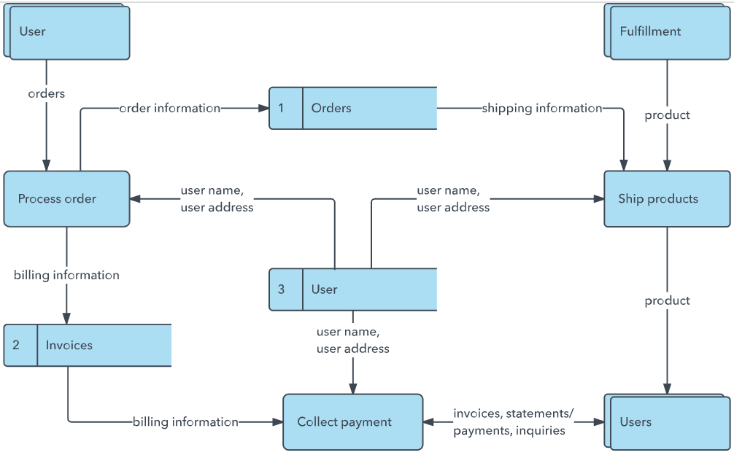


User Stories
Use the below template to list all the user stories for the product.
User Type | Functional Requirement (Epic) | User Story Number | User Story / Task | Acceptance criteria | Priority | Release
User | Authentication | USN-1 | As a user, I can securely register and sign in. | Valid credentials create a session/token and invalid input is rejected. | High | Sprint-1
User | Profile & Goals | USN-2 | As a user, I can manage my profile, goals and consent. | Authorized changes are saved and unauthorized access is blocked. | High | Sprint-1
Developer | API Access | USN-3 | As a developer, I can authenticate API requests and receive documented JSON responses. | Valid token works; invalid/expired token returns an appropriate error. | High | Sprint-1
User | Activity Tracking | USN-4 | As a user, I can submit workout/activity records. | Valid data is stored; invalid fields return validation errors. | High | Sprint-2
User | History | USN-5 | As a user, I can retrieve my activity history. | Only authorized records are returned in a consistent format. | High | Sprint-2
User | AI Insights | USN-6 | As a user, I can request an AI-generated fitness summary. | The API returns a structured insight based only on permitted data. | High | Sprint-3
User | Analytics | USN-7 | As a user, I can view progress trends and weekly summaries. | The API returns calculated metrics and time-period summaries. | Medium | Sprint-3
Administrator | Monitoring | USN-8 | As an administrator, I can view API health, errors and audit events. | Authorized administrators can view logs and service health. | High | Sprint-4
Administrator | Security | USN-9 | As an administrator, I can manage access and revoke compromised credentials. | Access changes take effect and are logged. | High | Sprint-4

DFD – Level 0 (Context)
User / Mobile App / Web App → AI FitTrack API → Authentication, Fitness Data, AI Insights and Analytics Services → Database / AI Model / External Integrations → Structured API Response.
DFD – Level 1
Request → API Gateway → Auth & Validation → Fitness Data Service → Database → AI Insight Service → Analytics/Response Formatter → JSON Response. Monitoring and audit logs receive security and operational events.

